Unit 2: Energy Transfer Technologies
Please use the information from the lesson to complete the guided notes right in the Google Doc. You have your own copy of notes for each lesson.

Thermal Energy, Heat, and Temperature
Have you ever wondered why a cup of hot coffee cools down on a kitchen counter, or why a metal spoon gets hot when left in a pot of boiling soup? It all comes down to how energy moves.
To understand energy transfer, we first need to know the difference between three very important words: temperature, thermal energy, and heat. People often use these words to mean the same thing, but in science, they are very different!

Particles in Motion
Remember what we learned in Unit 1......... Everything around us is made of tiny particles (atoms and molecules). These particles are always moving. The energy of moving objects is called kinetic energy.

1. What is Temperature?
Temperature is a measure of the average kinetic energy of the particles in a substance.
- If particles move fast, the temperature is high (hot).
- If particles move slowly, the temperature is low (cold).
- We measure temperature using a thermometer, usually in degrees Celsius (°C).

2. What is Thermal Energy?
Thermal energy is the total kinetic energy of all the particles in a substance.
Because it is a total, the amount of the substance matters! A large pot of boiling water has more thermal energy than a small cup of boiling water, even though they are at the exact same temperature. There are simply more moving particles in the large pot.

3. What is Heat?
Heat is the movement or transfer of thermal energy from one object to another.
Energy always flows in one direction: from the warmer object to the cooler object. When you hold an ice cube, it feels cold because heat is leaving your hand and moving into the ice.

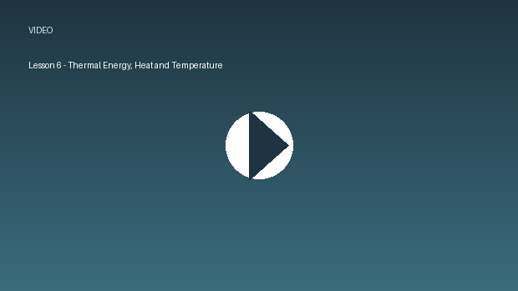
../02_SUPPORTING_FILES_BY_UNIT/Linked Media/Lesson 6 - Thermal Energy, Hea-a75503df5b.mp4

4. Comparing Temperature, Thermal Energy, and Heat
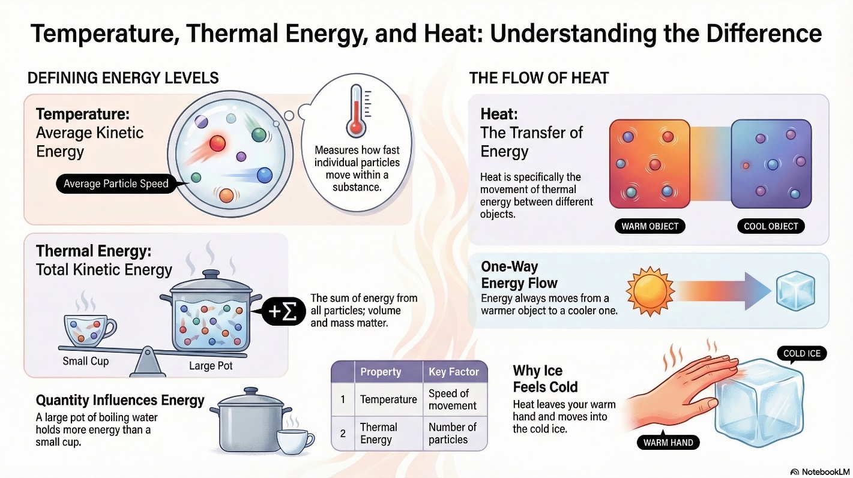

5. Real-World Safety: Respecting Heat
In everyday life and in the workplace, moving thermal energy can be dangerous. Fast-moving particles can cause severe burns or start fires.
- In the Home: Never touch a hot stove directly. We use oven mitts because they slow down the transfer of heat to our hands.
- In the Workplace: Many jobs involve extreme heat, such as welding, cooking, or working with engines
- Workers must use personal protective equipment (PPE) like insulated gloves, face shields, and heat-resistant clothing.
- Always pay attention to warning labels and safety symbols on equipment that generates high temperatures!

PPE for Welding:
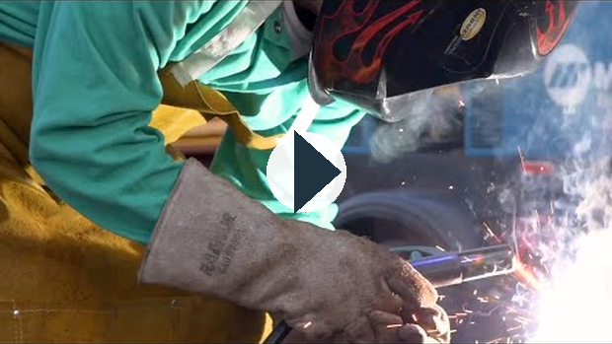
https://www.youtube.com/watch?v=YsAmLFF03jI

Lesson 6 Self-Check
Supporting file: 02_SUPPORTING_FILES_BY_UNIT/02 - Unit 2 Energy Transfer Technologies/Lesson 6 Self-Check-d33f9ab6d6.xml
Original package path: ccres0000028/ccres0000028.xml

Purpose: You are going to create a Google Slides presentation to demonstrate your understanding of thermal energy, heat and temperature.

Directions:
- Open up the Google Doc assignment and read through the directions & instructions.
- Open up the Google Slides template included in this assignment.
- Make sure to include all necessary information required in each slide outlined in the directions.
- Submit the assignment when finished.
Please use the information from the lesson to complete the guided notes right in the Google Doc. You have your own copy of notes for each lesson.

Lesson 7: The Transfer of Heat

Conduction, Convection and Radiation
Now that we have learned how particles behave in hot and cold substances, we need to explore the ways heat moves around in the surrounding environment……….

1. Conduction:
- Conduction is the transfer of heat by contact between two substances.
- When two substances are touching, heat energy is transferred from the molecules in the HOT substance to the particles in the COLD substance.
- For example, when a metal pot of water is placed on a hot burner on a stove.
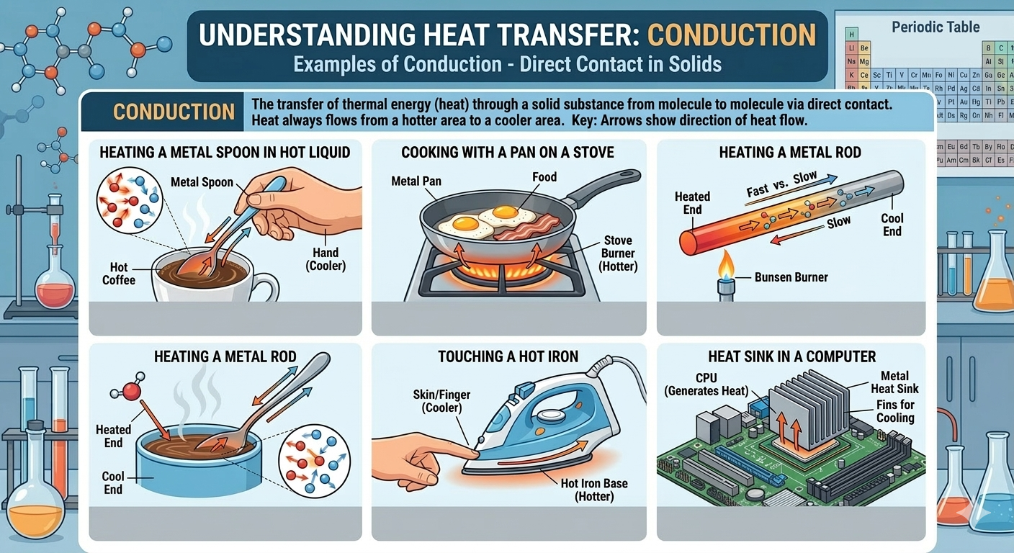

2. Convection:
- Convection is the transfer of heat through liquids and gases (fluids).
- When warmed, particles in fluids will rise above the cooler fluid.
- As the warmer fluid cools the particles move closer together making it more dense. This increase in density causes the fluid to sink.
- As their particles move farther apart, other warmed particles will replace the old particles and rise to the surface. This creates a Convection Current.
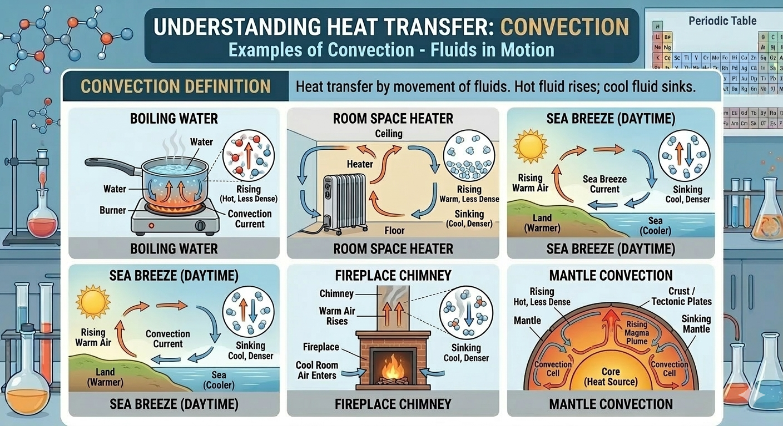

3. Radiation:
- The transfer of energy without the movement of matter.
- This energy is electromagnetic radiation (EMR) or Radiant Energy.
- Radiant heat energy can come from the sun, fire or any hot object. You are giving off radiant heat energy to the surrounding room right now!

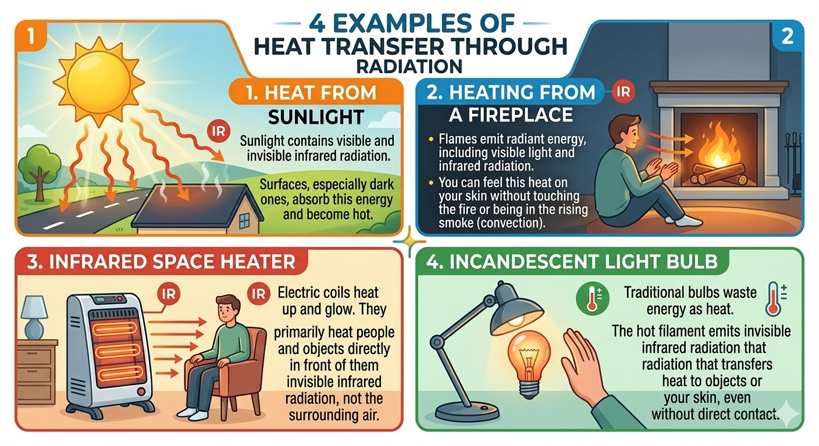

Watch the video below on Conduction, Convection and Radiation
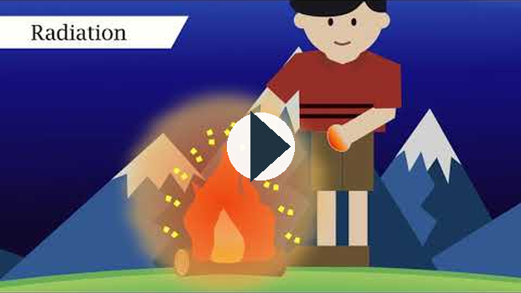
https://www.youtube.com/watch?v=lvyCe0UaqJY

Lesson 7 Self Check
Supporting file: 02_SUPPORTING_FILES_BY_UNIT/02 - Unit 2 Energy Transfer Technologies/Lesson 7 Self Check-e06f44a6dc.xml
Original package path: ccres0000029/ccres0000029.xml

Lesson 7 Video Assignment - Heat Transfer in Action

Directions:
- Watch the Video:
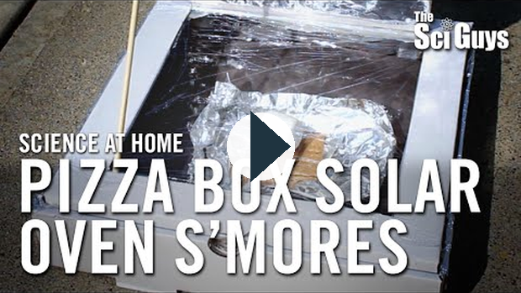
https://www.youtube.com/watch?v=pjsrRi2Bxl0

https://www.youtube.com/watch?v=pjsrRi2Bxl0
- the link is also in the assignment
- Pause or rewatch parts of the video to answer the questions in the asssignment
- Answer all of the questions to the best of your ability
Please use the information from the lesson to complete the guided notes right in the Google Doc. You have your own copy of notes for each lesson.

Lesson 8: Simple Machines

1. Energy
Lessons 6 and 7 were all about heat as a form of energy (thermal energy) causing particles in substances to speed up or slow down. There are, however, many other types of energy all around us that we experience on a daily basis. See the table below for a summary:

Types of Energy | Explanation | Example
Kinetic Energy | Energy of MOTION - objects in motion have kinetic energy. | Riding a bike  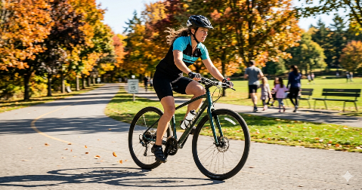
Potential Energy | STORED energy - energy waiting to be used/released. | Roller coaster at top of hill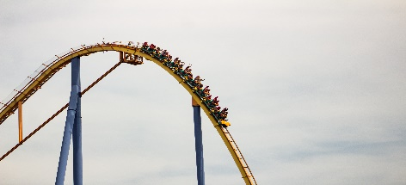
Thermal Energy | HEAT - objects transfer heat to one another | Campfire radiates heat energy  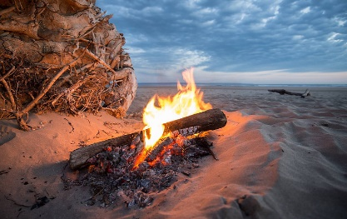

2. What are Simple Machines?
A machine is a device that helps us do work by changing the amount of force we need to apply or the distance over which we apply it. In our daily lives, we use many simple machines without even thinking about them.
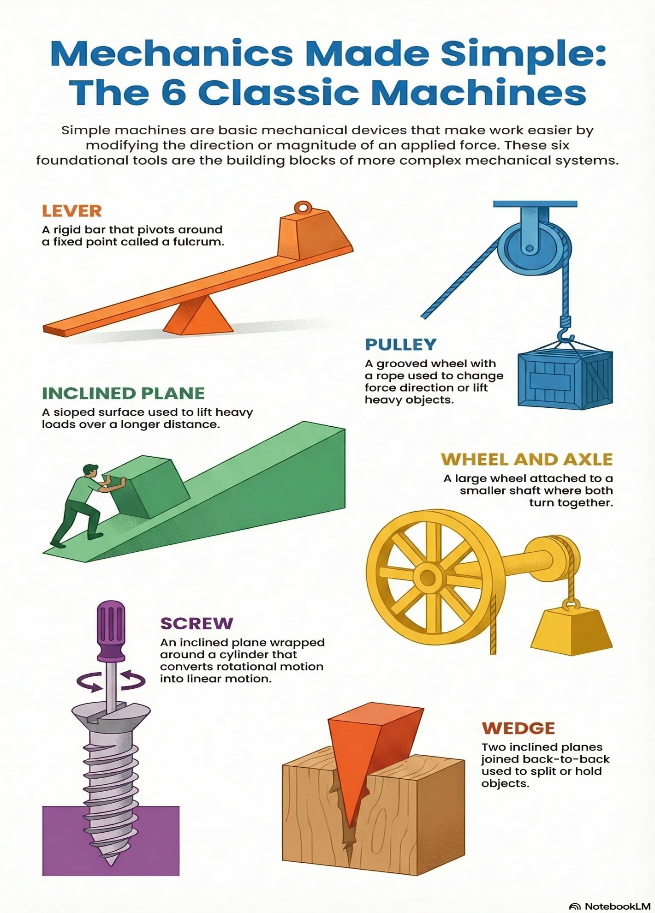

Watch this video for more explanations and examples of simple machines.
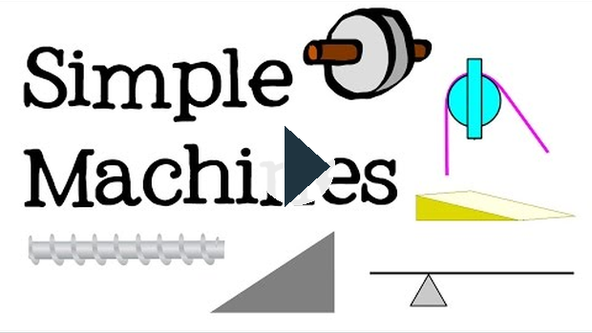
https://www.youtube.com/watch?v=fvOmaf2GfCY

3. Force Multipliers vs. Distance Multipliers
Most machines fall into two main categories based on how they help us. They either multiply our strength (force) or increase how far something moves (distance).

A. Force Multipliers
Main Goal: A force multiplier is a machine that allows you to move a large load with a small amount of effort.
Your Effort: You apply a small force over a long distance to move a heavy object a short distance.
Result: A large force is produced
- Household Example: A car jack. You pump the handle many times (large distance) with a small amount of effort to lift a very heavy car a few inches (large force).
- Workplace Example: A ramp (inclined plane) used to roll heavy boxes into a delivery truck.


B. Distance Multipliers
Main Goal: A distance multiplier is a machine that moves a load through a long distance using a large amount of effort over a short distance. These machines are used when you want to move something further or faster.
Your Effort: You apply a large force over a short distance
Result: A long distance is covered.
- Household Example: A broom. Upper hand moves a short distance with a large force, while the bottom of the broom moves a long distance.
- Workplace Example: Fishing rods or axes. Your hands are close together when applying for to the handle of each one.
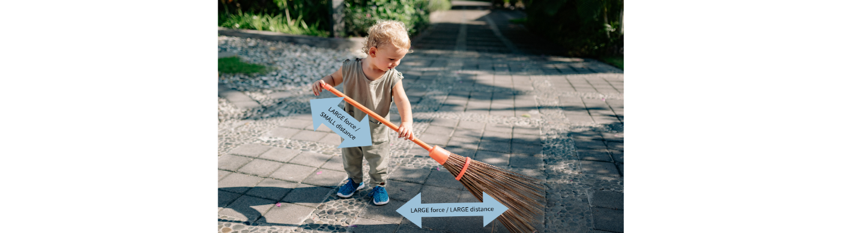

4. Safety and Efficiency
Using simple machines safely is crucial in the workplace and at home.
- Maintenance: Keep machines clean and lubricated to reduce friction. Friction creates unwanted heat and makes the machine less efficient.
- Proper Use: Always use the right tool for the job. For example, using a screwdriver as a lever (crowbar) can cause the tool to break and lead to injury.


../02_SUPPORTING_FILES_BY_UNIT/Linked Media/Lesson 8-8b1e3cd673.mp4

Lesson 8 Self Check
Supporting file: 02_SUPPORTING_FILES_BY_UNIT/02 - Unit 2 Energy Transfer Technologies/Lesson 8 Self Check-91c20e0fe0.xml
Original package path: ccres0000030/ccres0000030.xml
Please use the information from the lesson to complete the guided notes right in the Google Doc. You have your own copy of notes for each lesson.

Lesson 9: Energy Efficiency and Conservation

1. What is Energy Efficiency?
Efficiency means using less energy to do the same amount of work. When a machine or a house is efficient, it does not waste energy as "lost" heat. Energy conservation is the habit of using less energy overall to protect our environment.
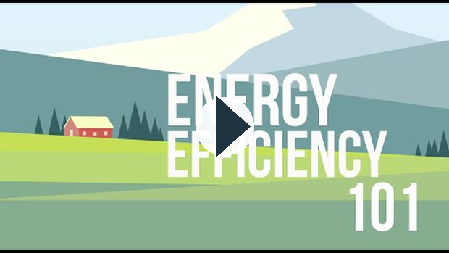
https://www.youtube.com/watch?v=D11iFUw_ImU

2. Keeping Heat In
To save energy at home, we need to stop heat from escaping. Many variables affect how quickly a building loses heat. Modern homes use special technologies to stay warm in the winter and cool in the summer.
Method | How it Works | Real-World Example
Insulation | Traps air to slow down heat transfer. | Fiberglass or spray-foam in walls.
Energy-efficient Windows | Uses multiple panes of glass to block heat loss. | Triple-pane windows in new houses.
Weather Stripping | Seals gaps around doors to stop drafts. | Rubber seals on the bottom of a front door.

3. Nonrenewable vs. Renewable Resources
Most of the energy we use today comes from nonrenewable resources. These are energy sources that will eventually run out, like coal, oil, and natural gas.
When we improve the efficiency of our cars and homes, we do not need to burn as much fuel. This helps us reduce our reliance on these limited resources and protects the environment for the future.
- Nonrenewable Resources: Energy sources that cannot be replaced quickly (e.g., Oil, Natural Gas, Coal).
- Renewable Resources: Energy sources that can be used over and over (e.g., Solar, Wind, Water).


../02_SUPPORTING_FILES_BY_UNIT/Linked Media/Lesson 9 - Energy Efficiency a-9d1b3d876d.mp4

4. Safety and the Environment
Being a good steward of the environment means making choices that reduce waste. At home, you can practice stewardship by:
- Turning off lights when you leave a room.
- Using a programmable thermostat to lower the heat at night.
- Choosing appliances with "Energy Star" labels that use less electricity.


https://www.youtube.com/watch?v=D11iFUw_ImU

Lesson 9 Self Check
Supporting file: 02_SUPPORTING_FILES_BY_UNIT/02 - Unit 2 Energy Transfer Technologies/Lesson 9 Self Check-d4d720311c.xml
Original package path: ccres0000031/ccres0000031.xml

Heating & Cooling Systems – Thermal Energy Transfer

1. Heat Always Moves from Hot → Cold
Heat (thermal energy) naturally flows from a warmer object to a cooler one until they reach the same temperature.
Cooling systems use this principle:
- Air conditioners move heat out of warm rooms into the outside air.
- Car radiators transfer heat from the hot engine to the cooler outside air.
Without this flow, systems would overheat or not cool down properly.

2. Three Ways Heat Transfers

a) Conduction
- Heat transfer by direct contact.
- Fast-moving particles bump into slower ones, passing along energy.
- Example: A metal spoon gets hot when left in a pot of soup.

b) Convection
- Heat transfer through moving fluids (liquids or gases).
- Warm fluid rises, cooler fluid sinks → creates convection currents.
- Example: Boiling water (bubbles rise), warm air rising to form wind.

c) Radiation
- Heat transfer by waves of energy (infrared radiation).
- Can happen through empty space (no particles needed).
- Example: Feeling the Sun’s warmth on your face, even in space.

3. Comparing Structures – Traditional vs. Contemporary
Contemporary houses: insulation, double-pane windows, furnaces, air conditioners. Designed to be energy efficient.
Traditional Aboriginal structures: used natural, practical designs for heat retention:
- Tipis: cone shape, adjustable flaps for air flow, hide coverings kept warmth inside.
- Igloos: compact snow structure, snow is a great insulator → heat from people + lamps stays inside.
Both designs show clever ways of keeping warm in different climates.

4. Particle Model of Matter
- All matter is made of tiny particles in constant motion.
- The higher the temperature, the faster the particles move.
- Example: Brownian motion – tiny dust or pollen grains jiggle randomly in water or air because they’re being hit by moving particles.
- Heat transfer happens because fast particles (hot) collide with slower particles (cold), sharing energy.

5. Convection & Conduction in Natural & Technological Systems
- Sea breezes: during the day, land heats faster than water → warm air rises over land, cool air from the sea rushes in.
- Land breezes: at night, land cools faster than water → warm air rises over the sea, cool air flows from land to water.
- Cast-iron pans: conduction spreads heat evenly through the pan.
- Heaters & furnaces: use convection currents to circulate warm air in a room.

6. How Water Moderates Climate
Large bodies of water (oceans, lakes) heat up and cool down more slowly than land.
This means areas near water have milder climates:
- Vancouver (near the Pacific Ocean): cooler summers, warmer winters.
- Calgary (farther inland): hotter summers, colder winters.
Water stores and releases heat slowly, creating a “buffer” against extreme temperatures.

Key Takeaways
Heat transfer = always hot → cold.
3 methods: conduction (contact), convection (fluid movement), radiation (waves).
Structures (modern + traditional) use clever heat retention strategies.
The particle model explains how heat works.
Water plays a huge role in moderating Earth’s climate.
Controlling the Transfer of Thermal Energy
Thermal energy (heat) is useful—but it can also be wasteful or dangerous. Humans have developed many methods and devices to control how heat moves.

1. Reducing Heat Transfer
Technologies that slow down or reduce heat transfer help us stay comfortable and save energy.
Clothing strategies:

Winter clothing (wool, down, layered jackets) traps air → insulation.
Summer clothing (light-coloured cotton) reflects sunlight, allowing heat to escape.
Insulation in buildings:

Fiberglass, foam, and cavity walls reduce conduction and convection.
Double-pane windows trap air between panes → slows heat loss.
Everyday examples:
Travel mugs keep drinks hot/cold by using insulating walls.
Coolers keep food cold on hot days.
By reducing heat transfer, we conserve energy and reduce costs.

2. Protection Against Dangerous Heat Transfer
Some situations require blocking or controlling intense heat for safety.
Household appliances:
- Ovens and stoves are insulated so heat stays inside.
- Toasters and kettles are designed with plastic/ceramic handles to prevent burns.
Protective clothing:
- Firefighter suits – made of special heat-resistant fabrics (like Nomex) that protect from flames and high temperatures.
- Oven mitts – thick, insulated fabric to stop burns.
Engines:
- Internal combustion engines use cooling systems (water + antifreeze radiators) to prevent overheating.
- Heat shields protect nearby components.
These devices keep people and machines safe when dealing with high heat.

3. How Heat Absorption & Loss Vary by Material
The way a substance absorbs or loses heat depends on its type and amount.
- Water vs. oils:
  - Water heats and cools slowly (high specific heat capacity).
  - Oils heat and cool faster.
  - This is why water moderates climate and why oil in a pan heats quickly.
- Metal vs. wood:
  - Metal conducts heat quickly → feels cold or hot right away.
  - Wood is a poor conductor (insulator) → safer for handles and utensils.
- Amount matters:
  - A large pot of water takes longer to heat and cool than a small cup.
By choosing materials wisely, engineers can design better insulators, cookware, or climate-control systems.

Key Takeaways
We use insulation, clothing, and building strategies to reduce heat transfer.
Protective technologies (firefighter suits, insulated appliances, engines) keep people and systems safe.
Different materials absorb and lose heat at different rates—engineers and designers use this knowledge to solve real-world problems.

Simple Machines – Force, Distance, and Energy

1. What Are Simple Machines?
A simple machine is any tool or device that transfers energy to make work easier.
They don’t create energy—they just change how energy and force are used.
Examples: screws, ramps, levers, hammers, hockey sticks, tennis rackets.
Think of them as “helpers” that allow you to apply a smaller force or move farther with less effort.

2. Force Multipliers vs. Distance Multipliers
Simple machines usually act in one of two ways:

Force Multipliers
Allow you to apply a smaller force to move a heavier load.
Example:
- Crowbar – pries heavy objects by applying little effort over a larger distance.
- Automobile jack – lifts a heavy car using a small force.
You trade distance for force: you move your end farther, but the machine multiplies your effort into a stronger force.

Distance Multipliers
Allow you to apply force over a greater distance to increase speed or range.
Example:
- Hockey stick – small movement of your hands creates a big swing at the end → puck travels fast.
- Tennis racket – multiplies the distance of your swing, transferring energy to the ball.
You trade force for distance: you use more force, but it carries farther and faster.

3. Common Household Simple Machines
Can opener – combines levers and gears, making it easy to cut through metal lids (force multiplier).
Scissors – two levers working together; multiply force to cut paper or fabric.
Hedge clippers – long handles act as levers; small effort becomes big cutting force.
Ramps (inclined planes) – reduce the force needed to move objects up by spreading the effort over a longer distance.
Screws – inclined plane wrapped around a cylinder; converts rotational energy into forward force (e.g., wood screw).
Hammers – transfer energy from your arm into the nail, pushing it into wood.

Key Takeaways
Simple machines transfer energy and make work easier.
They can be force multipliers (increase strength, but you move farther) or distance multipliers (increase range/speed, but you use more force).
Everyday tools—from can openers to sports equipment—use these principles to save time and effort.

